Why Stuff Happens

- Quick Check – Entropy

Consider the following reactions. State if the reactants or products have higher/more entropy:

- CaCO₃ (s) CaO (s) + CO₂ (g) . . . . . . . . . . . . . . . . . . . . . . . . . . . Products

- N₂ (g) + 3H₂ (g) 2NH₃ (g) . . . . . . . . . . . . . . . . . . . . . . . . . . . . . Reactants

- CH₃COO⁻Na⁺ (aq) CH₃COO⁻Na⁺ (s) . . . . . . . . . . . . . . . . . . . . Reactants

- NaCl (s) NaCl (aq) . . . . . . . . . . . . . . . . . . . . . . . . . . . . . . . . . . . . Products

- 2H₂O (l) 2 H₂ (g) + O₂ (g) . . . . . . . . . . . . . . . . . . . . . . . . . . . . . Products

- The Problem

We usually expect a system to go from a less to more stable state.

Increased stability implies a lower energy state.

Which is the better choice, exothermic or endothermic, when considering if a reaction will take place or not?

Exothermic
Why do you say this? 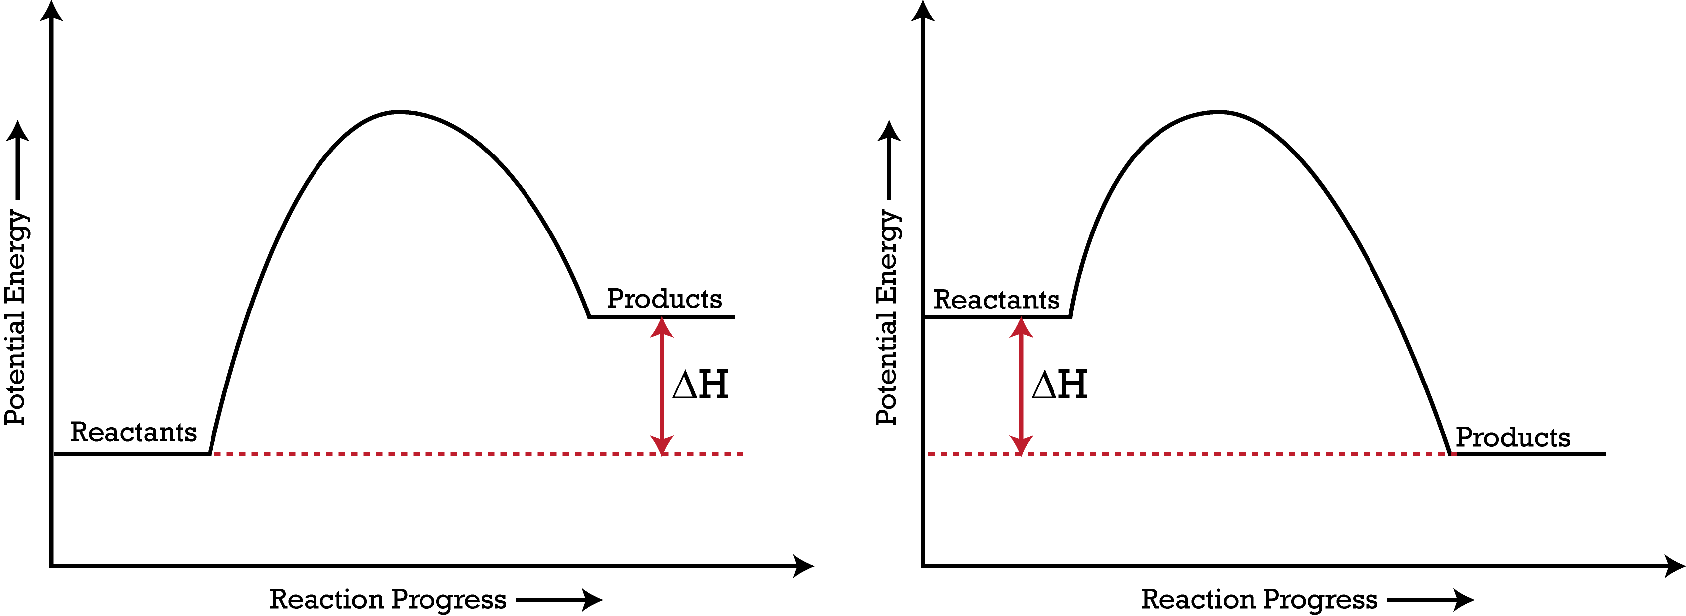
Sketch a simple diagram to explain your choice.

- Experiments/Demonstrations

- The Imploding Bottle (NaOH and CO₂)

Question | Observation/Answer
Upon addition of the tablets, a whole lot of CO₂ (g) was produced. At this point, is the entropy of the system high or low? | Entropy of system is high.
What changed upon adding NaOH (aq)? What can you say about the entropy change of the system? | The bottle collapsed. The gas had reacted with NaOH (aq). There is a decrease in entropy.
Was the bottle warm to the touch? What does this tell us about the enthalpy change of the reaction or system? | Bottle is a little warm. Entropy change of reaction is negative, i.e. exothermic.
Write the chemical reaction for this reaction. State if the entropy increased or decreased on going from reactants to products. | CO₂ (g) + NaOH (aq) NaHCO₃ (aq)  Entropy decreased.

- Solid and Solid (Ba(OH)₂ and NH₄Cl)

Question | Observation/Answer
How did the consistency change upon mixing the two solids together? How is the entropy changing? | The two solids formed a slurry, i.e. sludgy consistency.  Entropy is increasing.
Was there any gas evolved? What was it? | Pungent gas evolved. Gas is most likely ammonia. Entropy of system is increasing significantly.
What special “heavy lifting” could the beaker do? Why could it do this? What was the enthalpy change? | The beaker could lift the mat. The thin film of water had frozen: the beaker was now “stuck” to the mat. The reaction is endothermic.
Write the chemical reaction for this reaction. State if the entropy increased or decreased on going from reactants to products. | Ba(OH)₂ (s) + 2NH₄Cl (s) BaCl₂ (aq) + 2H₂O (l)  + 2NH₃ (g)  Entropy of system has increased significantly.

So what’s “strange” here?

- Solid reacted with another solid

- Endothermic reaction occurred very readily

What’s the missing link and why do things happen?

- The Second Law of Thermodynamics (The Crux of It All)

The entropy of the universe always increases in the course of a spontaneous reaction.

dS_{univ} > 0

dS_{univ} = dS_{sys} + dS_{surr}

What is entropy?

Entropy is a vaguely defined as the extent or degree of disorder in a system. The higher the disorder or the more random the system is (i.e. more permutations to configure its constituent particles) the higher the entropy.

What can we do or supply to bring the system from the representation on the left to that on the right (see Figure 1)?

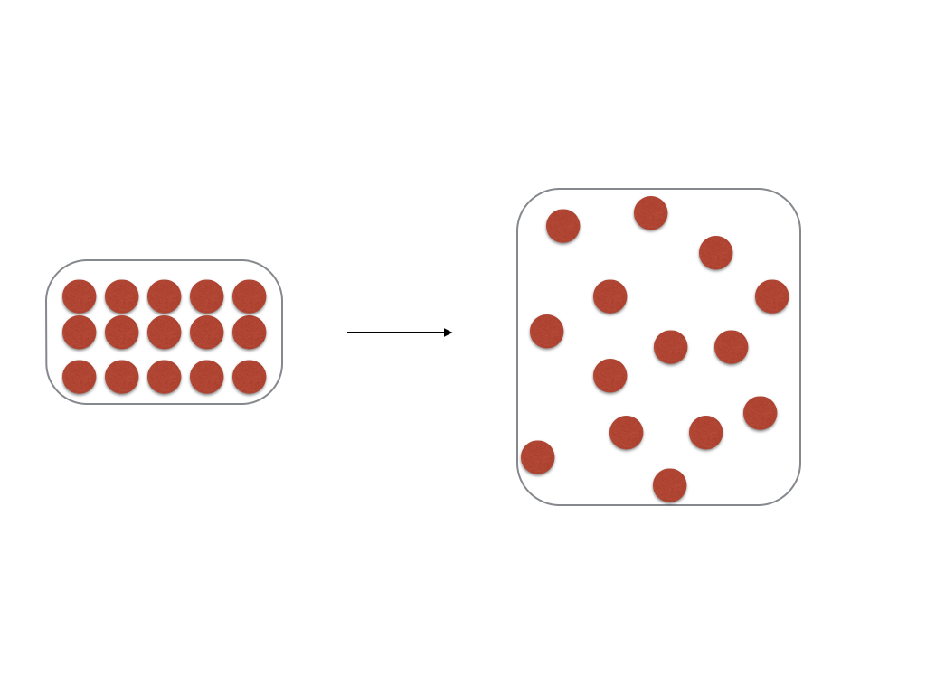
Figure 1 - Change in disorder

Supply thermal energy or heat the system

The more heat or thermal energy supplied, the higher the entropy.

It seems like the change in entropy is directly proportional to the

heat supplied.

Now let’s consider the extent of the change of entropy.

Draw, in the space below, the change in organisation of particles on going from (a) 1 pK to 100 K and (b) 3001 K to 3101 K for any species (e.g. helium or silicon).

It seems like the change in entropy is indirectly proportional to the

temperature at which the chemical or physical process occurs.

- Play with the equation and give it meaning.

In the following (generic and rather rough derivation), we see how we assign meaning to an equation by simply playing with it.

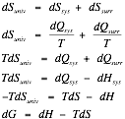

dG = -TdS_{univ}

Since dS_{univ} is greater than zero for a spontaneous change, we must have dG < 0 for the same spontaneous change (since T is absolute and is always greater than 0).

- Rearrange that equation and see what it means!

dH = dG + TdS

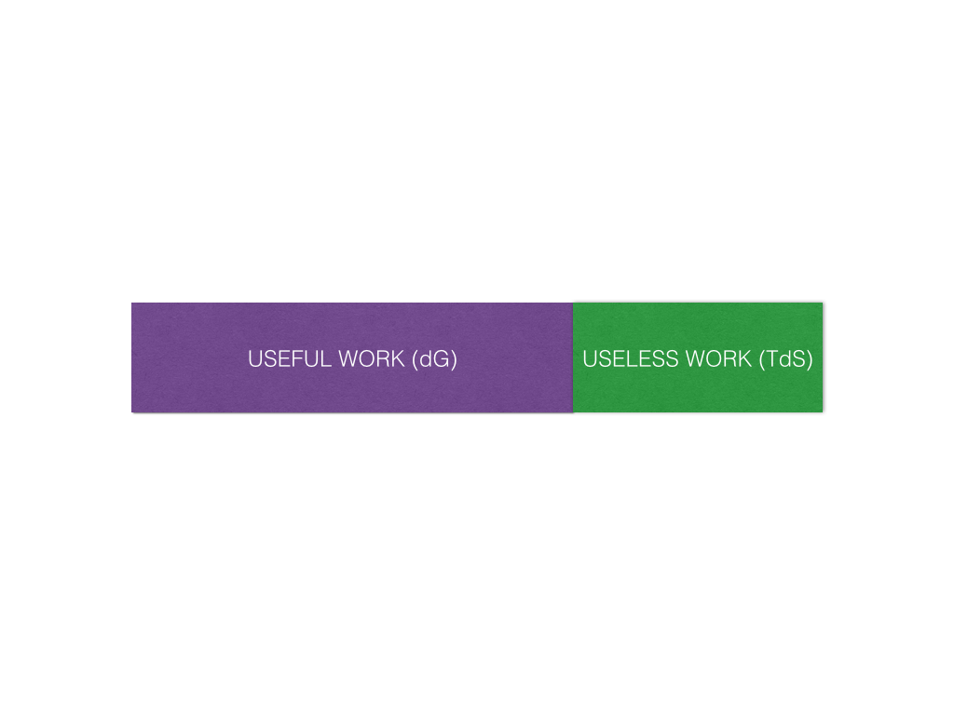

- Varying extents of dG (slightly negative, very negative, slightly positive, very positive)

The ‘drooping shoelace’

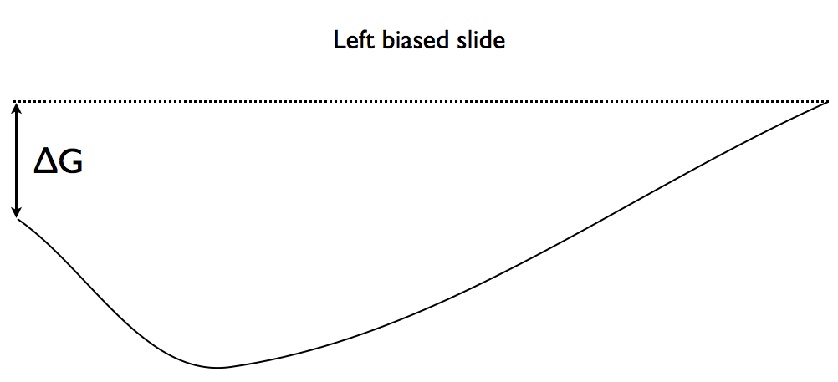
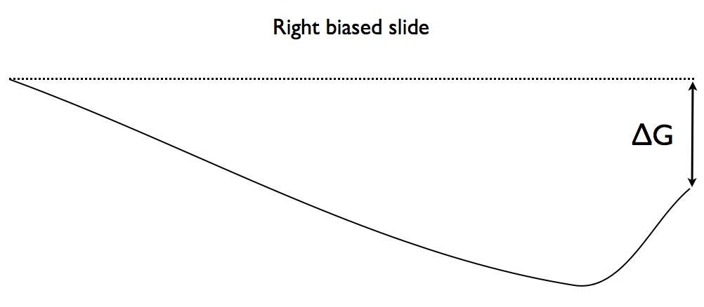
Are there reactants and products at the end of the reaction? Both

However, there is a greater proportion of reactants (products) than

products (reactants) because dG is slightly positive (negative).

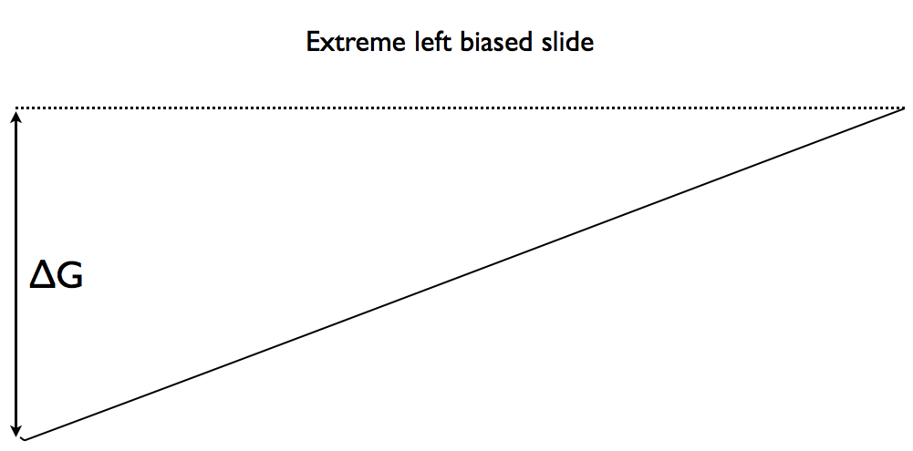

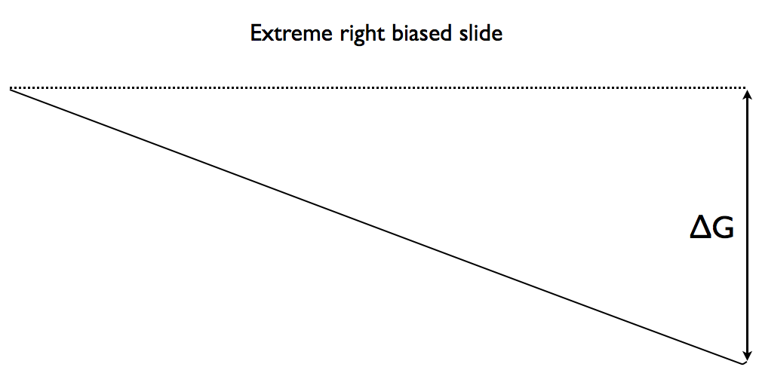
Are there reactants and products at the end of the reaction? Both

However, there is almost only reactants (products) and nearly no

products (reactants) because dG if very positive (negative).
- Application to improving yields of reactions.

- Would you use a high a low temperature when carrying out organic synthesis of the form A + B C (where all are in the same state/phase)

There is a decrease in entropy.

A low temperature should be used to “mask” the dS term.

- Would you use a high or low temperature when carrying out synthesis of the form A B + C (where C is in the gaseous state and A & B are in the solid state).

There is an increase in entropy.

A higher temperature should be used to “accentuate” the dS term.

- Permutations

dH | dS | dG | Feasibility
- | + | - | Spontaneous
- | - | ? (Depends) | Temperature dependency
+ | + | ? (Depends) | Temperature dependency
+ | - | + | Not spontaneous

- Problem

Try to prove the most overlooked statement: Thermal energy ‘flows’ from high to low temperature (clue: 2nd Law).

